This is why the police kill so many black people – and it’s not what you expect

[Rob Waugh](http://metro.co.uk/author/rob-waugh/)

[Rob Waugh for Metro.co.uk](http://metro.co.uk/author/rob-waugh/)Tuesday 26 Jul 2016 1:54 pm

[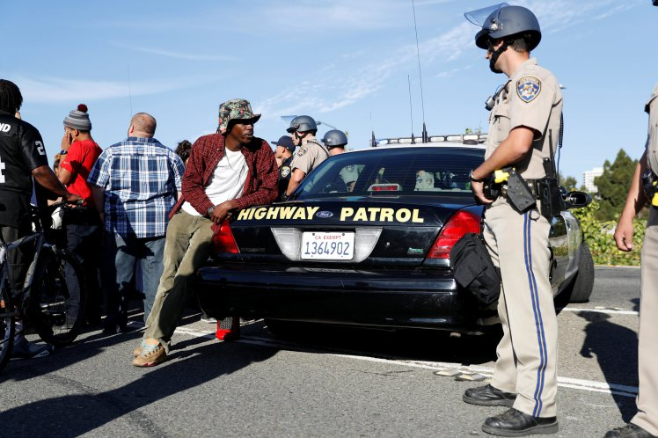](https://metrouk2.files.wordpress.com/2016/07/ad_213967590.jpg?quality=80&strip=all&strip=all)

Recent police shootings have ignited protests across America REUTERS/Stephen Lam – RTSI8DR

The recent shocking deaths of black people at the hands of the police has turned into a huge issue in America – with protesters taking to the streets.

But a new study in BMJ journal Injury Prevention has thrown light on why black people are actually killed.

Police are just as likely to kill whites in stop-and-search incidents, the study found: but police officers are far more likely to stop and arrest black people.

In 2012, American police killed 1,000 people in stop-and-search incidents – and injured a further 54,000, according to the[LA Times](http://www.latimes.com/science/sciencenow/la-sci-sn-cops-race-injury-20160725-snap-story.html).

Lead author Ted Miller said, ‘Certainly the dialogue we’re hearing is that there are a lot more minorities being killed. And I was expecting to see that the likelihood of being killed was higher if you’re a minority.

‘It turns out that once the police have stopped you, there is not a racial difference in the likelihood of your being seriously hurt.’

The researchers found that when African Americans or Latinos are stopped by the police, they are arrested in 82-85% of cases – but when whites are stopped, they are arrested 70% of the time

Read more: <http://metro.co.uk/2016/07/26/this-is-why-the-police-kill-so-many-black-people-and-its-not-what-you-expect-6030228/#ixzz4NXVlZunk>